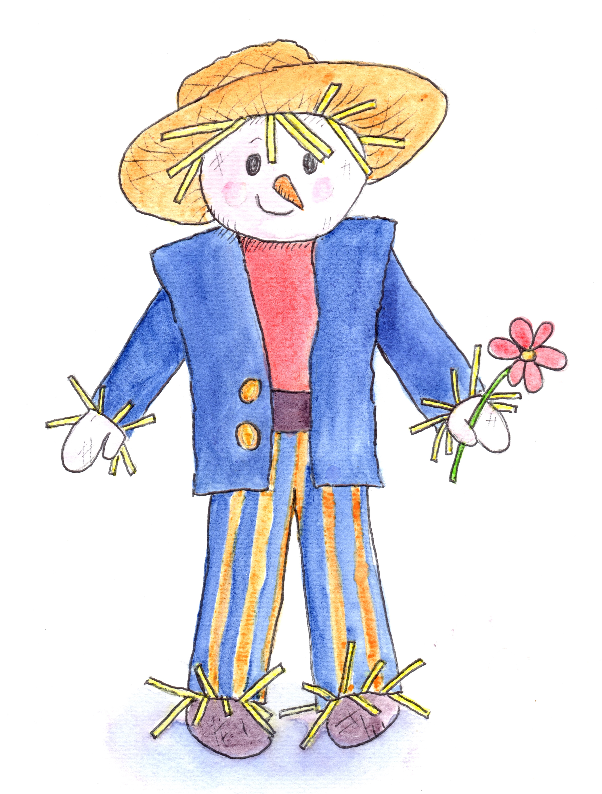

Chatter Matters in the Garden
at Hill Close Gardens. Week 1

Introduction Welcome, housekeeping. Books, toys and treasure baskets containing natural objects.

Session Focus Being Face to Face
Explanation of strategy for parents

Songs Hello Song followed by Head, shoulders, knees & toes
Row, row, row, your boat

Instruments Peter choose a sound
Let’s all shake together

Storytime Baby Goz – When I grow up by Steve Weatherill

(Props) Baby Goz Storysack including Goz, squirrel,
frog, butterfly

Activities Butterflies on sticks
Cress caterpillars
Mirrors – reflections
Water tray and ducks

Garden Walk Butterfly spotting in the garden

Snack Time

Songs Three little ducks went swimming one day
Humpty Dumpty
Bye Bye Song

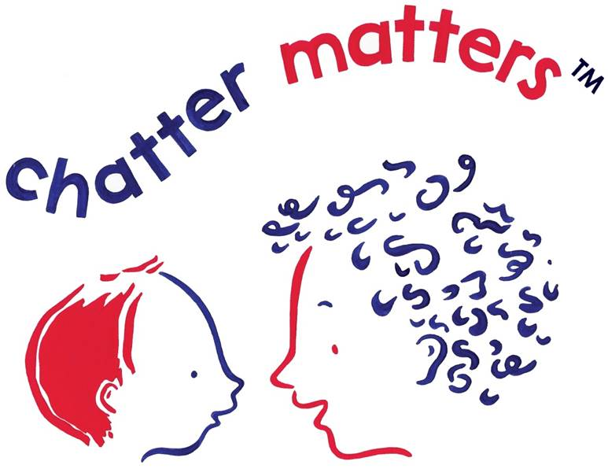Remember Chatter Matters at Home

