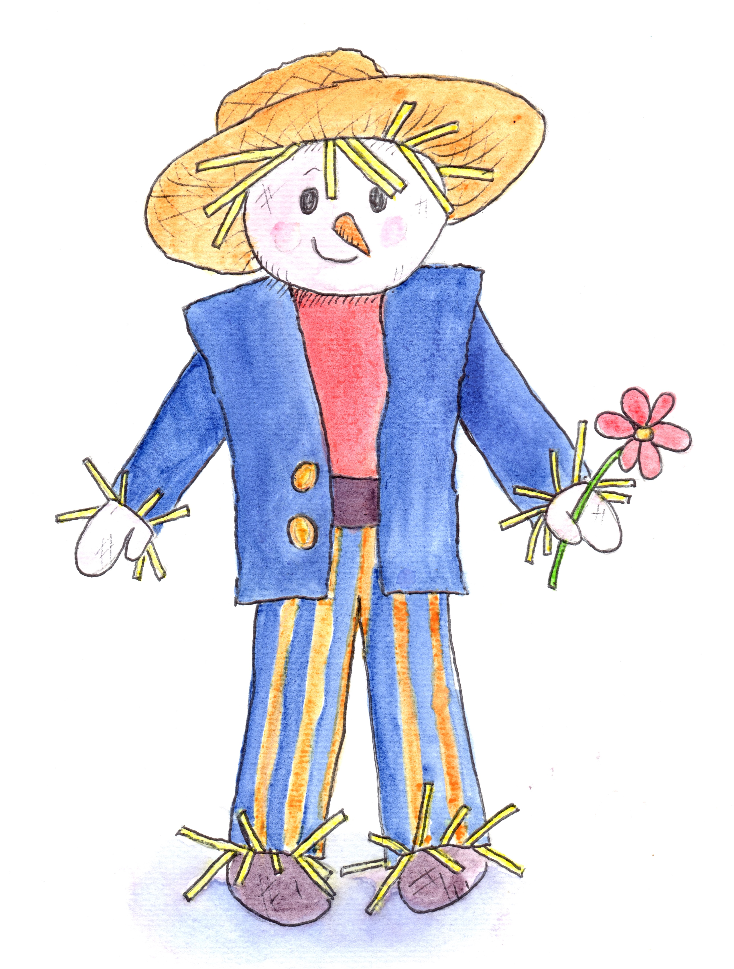

Chatter Matters in the Garden
at Hill Close Gardens Week 6

Introduction Welcome. Books, toys & treasure baskets out

Session Focus Using Repetition and Match and Add

Songs Hello Song followed by Jack in the Box
Jelly on a Plate
Open, Shut Them

Instruments Peter choose a sound
Let’s all clap together
Everybody do this

Storytime Oliver’s Vegetables by Vivian French

(Props) Vegetables features in story
(carrots, spinach, rhubarb, cabbage
beetroot, peas, potatoes.)

Activity/activities Vegetable printing
Make a dangly scarecrow
Digging and sweeping in the garden
? Emptying a potato bag

Garden Walk Vegetable spotting in the garden

Snack Time

Songs Bicycle song
Little Peter Rabbit
Bye Bye Song

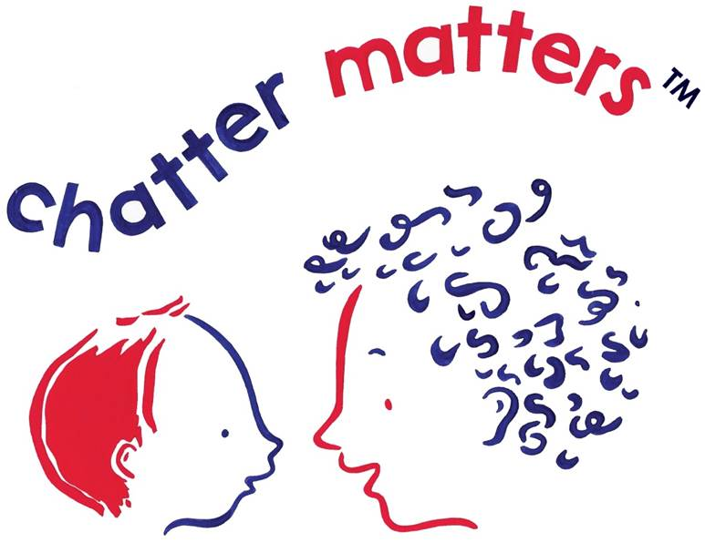
Remember Chatter Matters at Home

