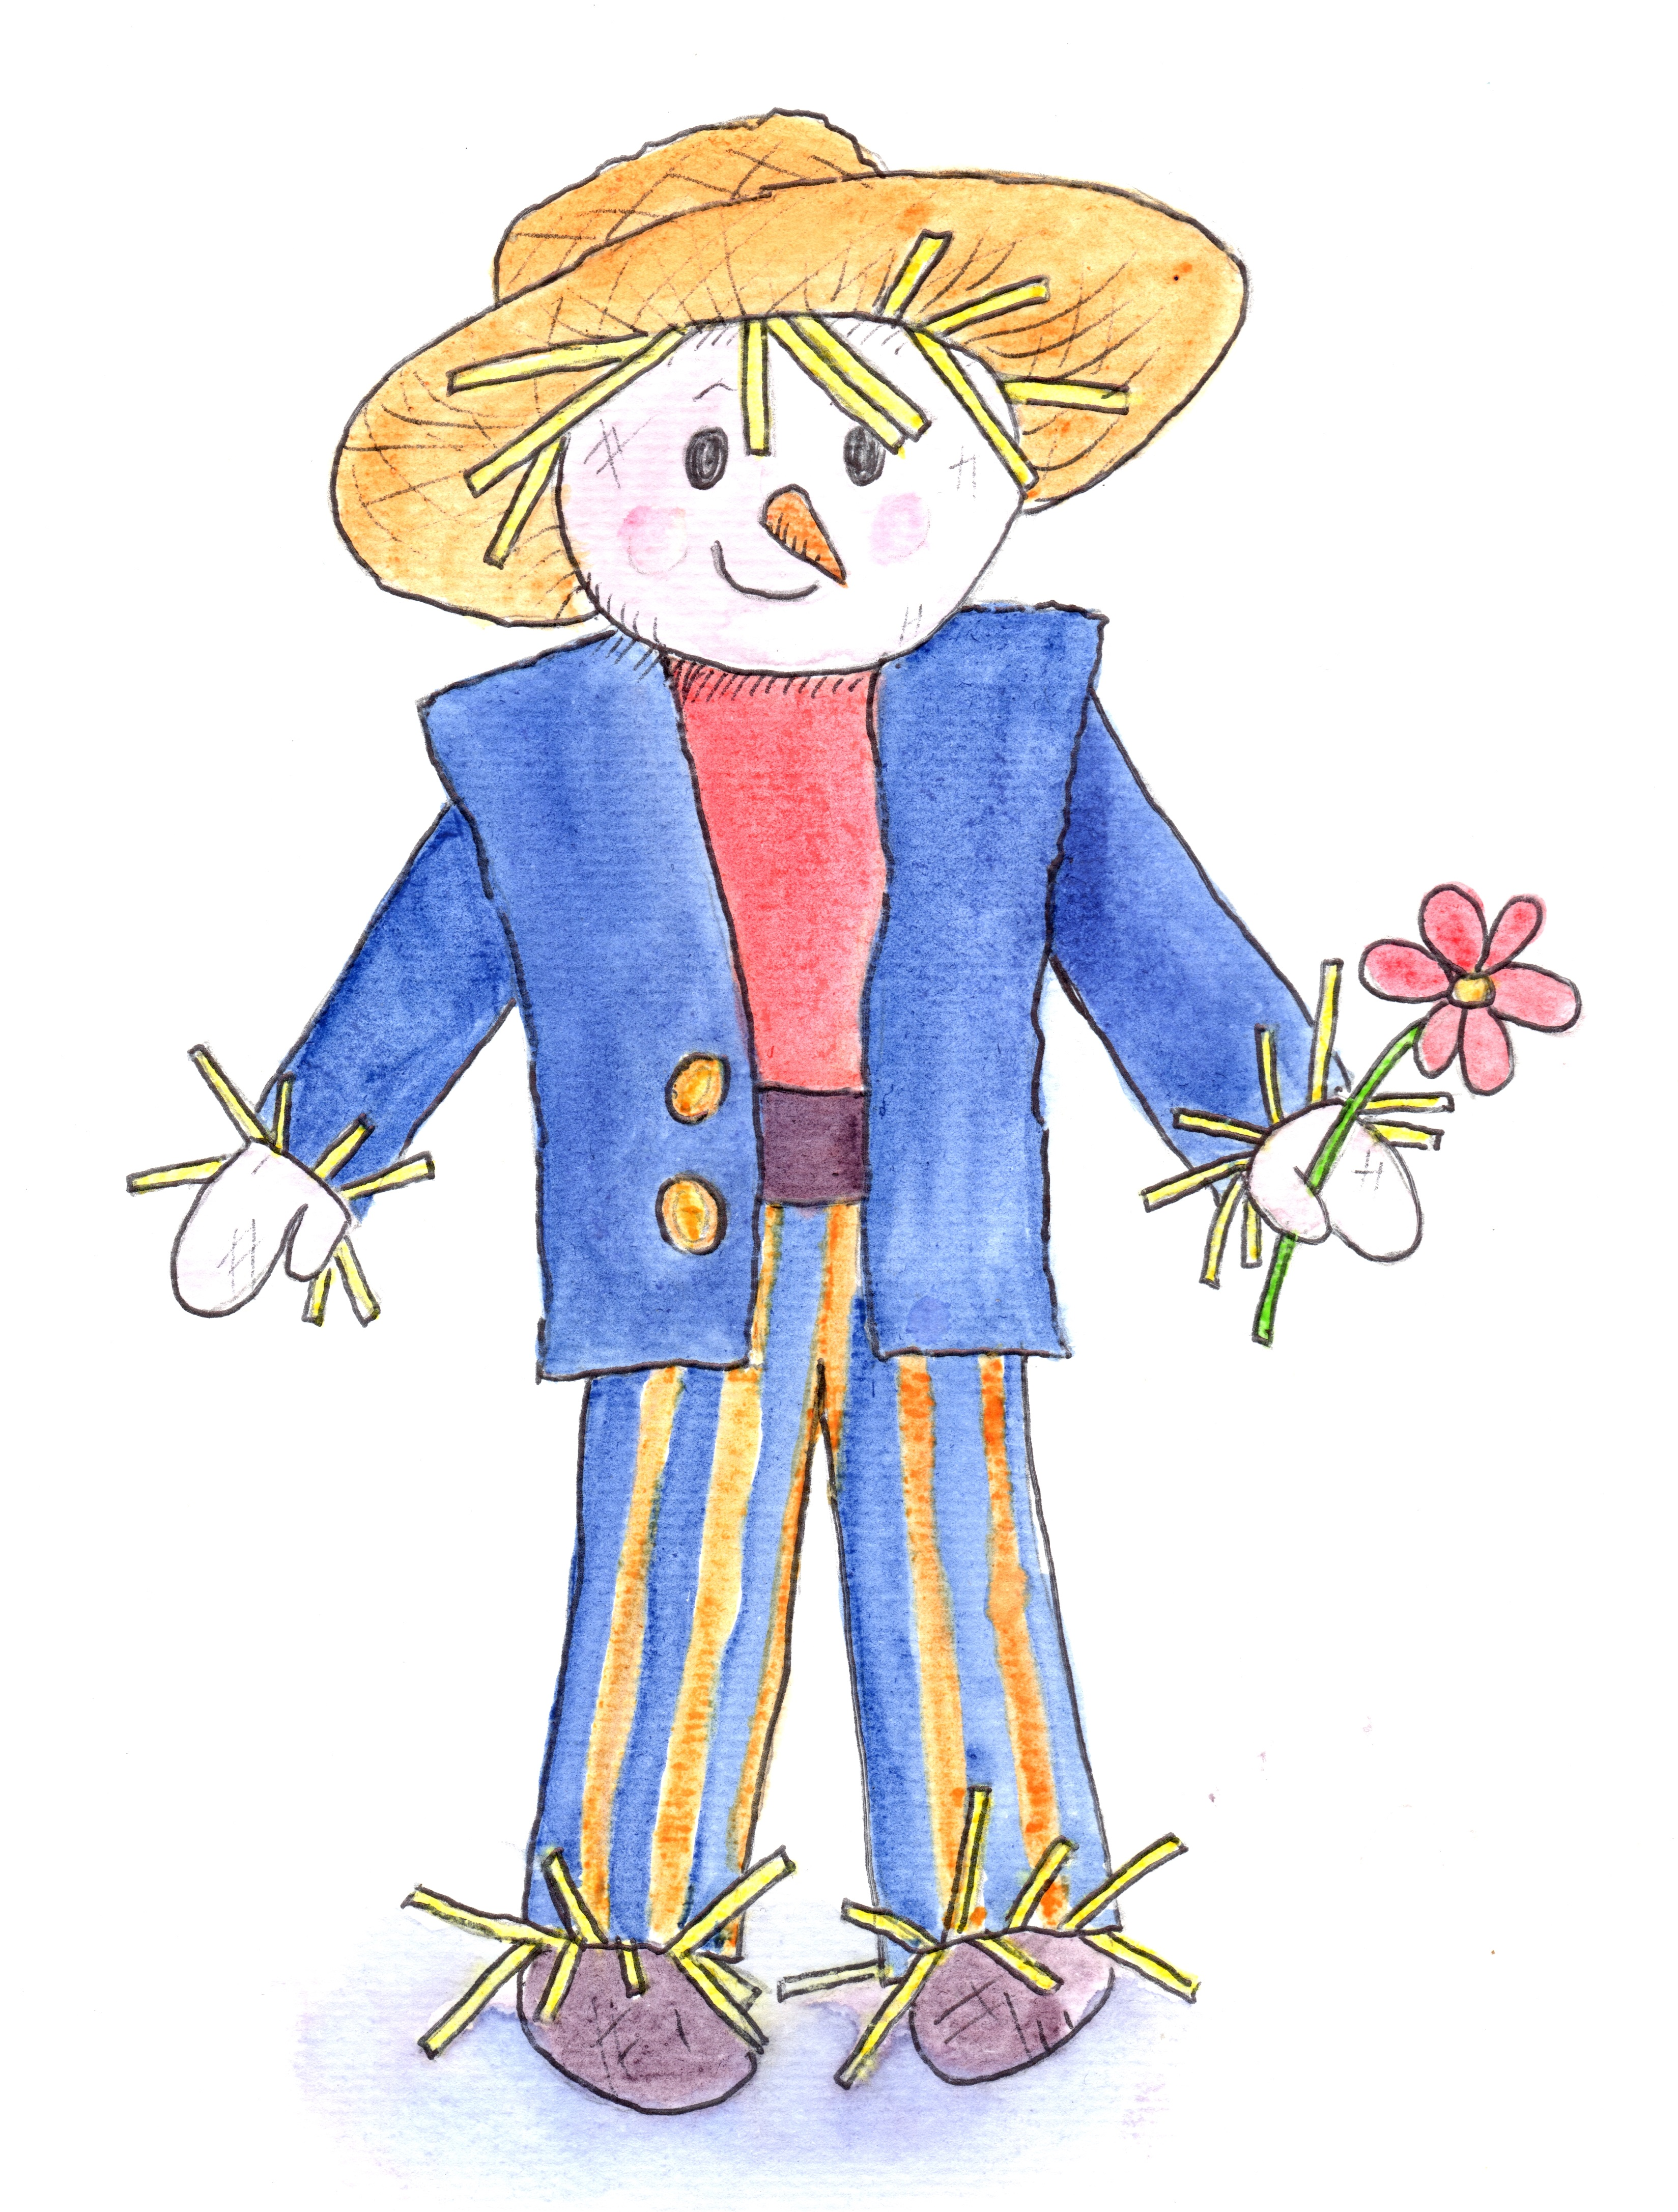

Chatter Matters in the Garden
at Hill Close Gardens Week 3

Introduction Welcome, books, toys and treasure baskets

Session Focus Talking to your child
Share strategies with parents.

Songs Hello Song followed by Open, shut them
Little Peter Rabbit
Jack in the Box

Instruments Peter choose a sound
Let’s all shake together

Storytime The Very Hungry Caterpillar by Eric Carle

(Props) Fruit – apple, pear, plum, strawberry, orange
Caterpillar, cocoon

Activities Bottle top caterpillars
Hanging butterflies
Wooden fruit threading
The very hungry caterpillar booklet

Garden Walk Spotting caterpillar and butterflies

Snack Time Fruit from the story

Songs There’s a tiny caterpillar on a leaf
Incy Wincy Spider
Bye Bye Song

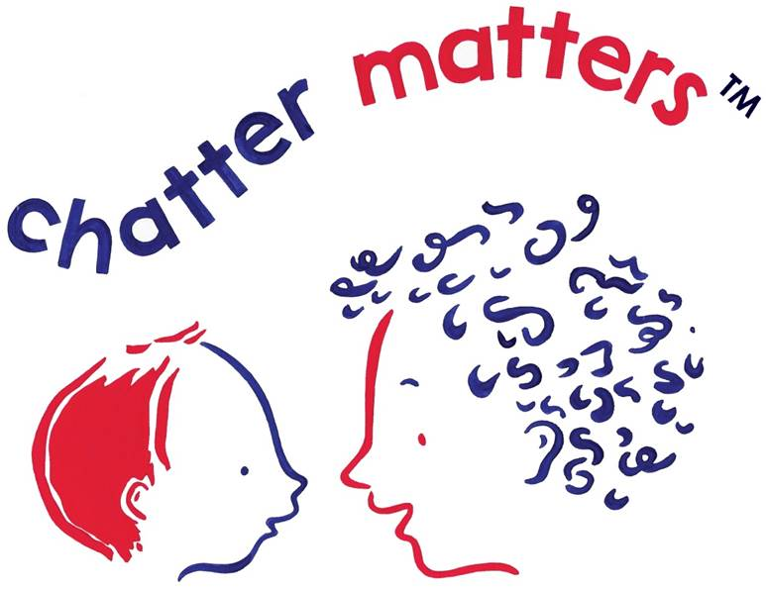
Remember Chatter Matters at Home

