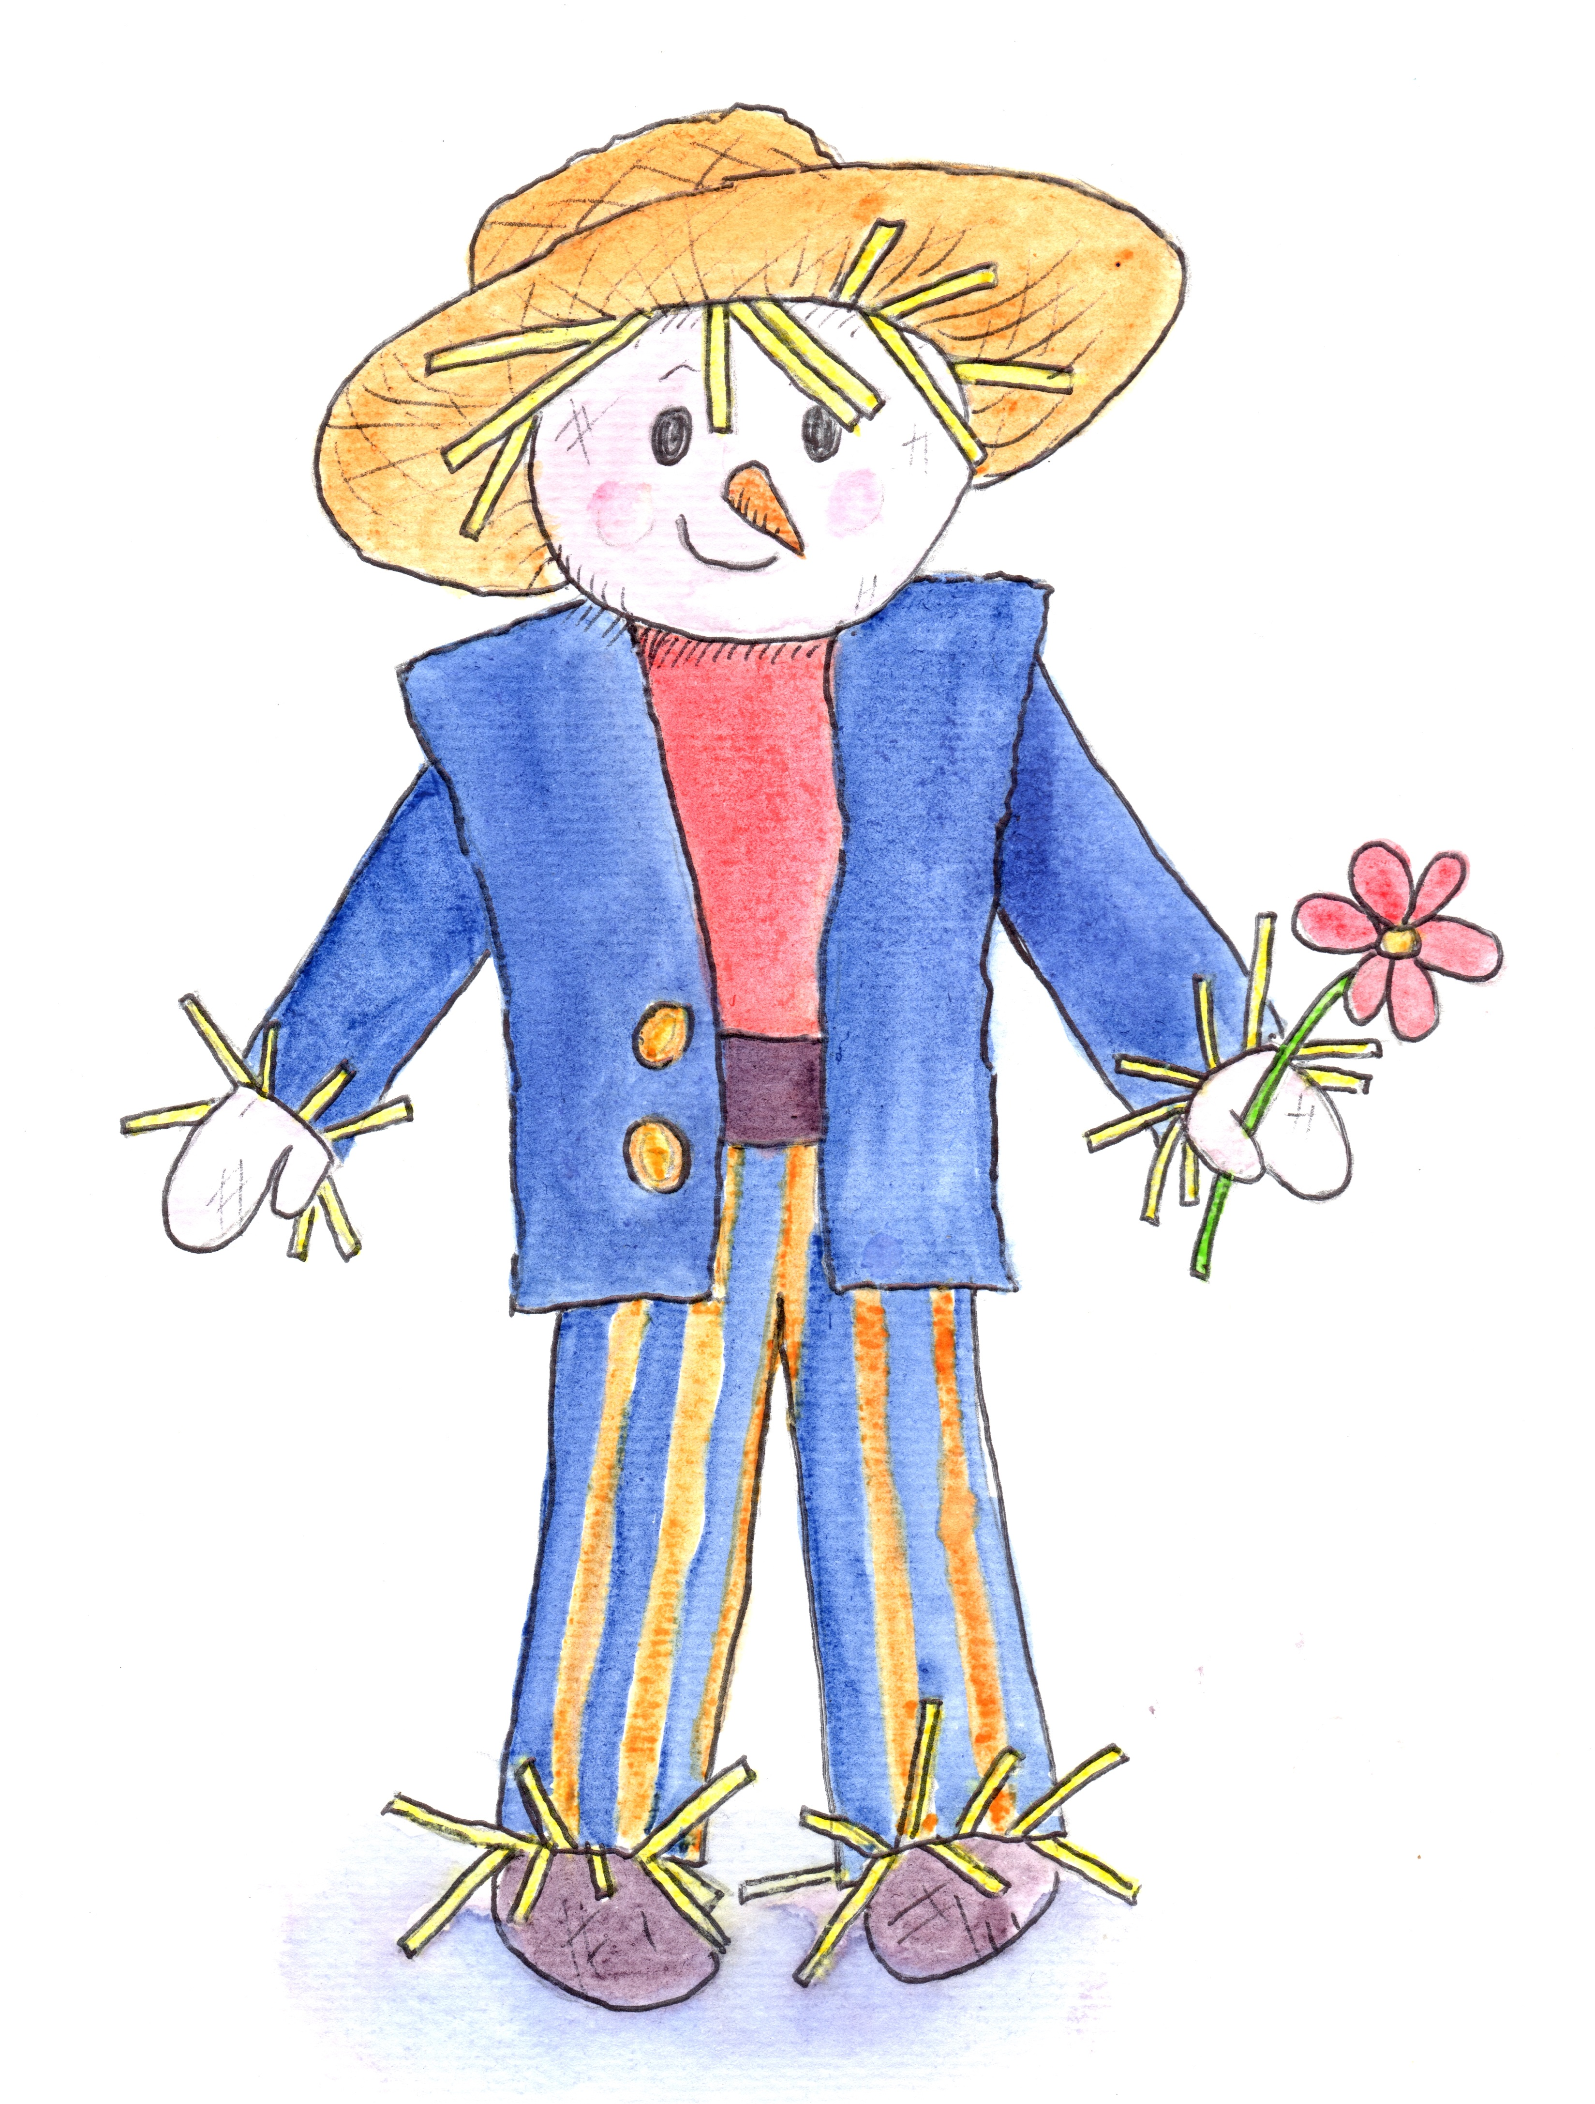

Chatter Matters in the Garden
at Hill Close Gardens Week 2

Introduction Welcome, books, toys and treasure baskets
containing metal objects.

Session Focus Joining In
Share strategies with parents

Songs Hello Song followed by Open, shut them
Head, shoulders, knees and toes
Round and round the garden

Instruments Peter choose a sound
Richard can you do this

Storytime Titch by Pat Hutchins

(Props) Drum, trumpet, whistle, saw, hammer, nails,
spade, flower pot, seed.

Activities Plant a seed to take home
Make kites and/or pinwheels
Digging and weeding in the garden
Building with different sized pots

Garden Walk Find the Flowerpot Man

Snack Time

Songs Can you play at peekaboo?
I’m floating
Twinkle, twinkle little star
Bye Bye Song

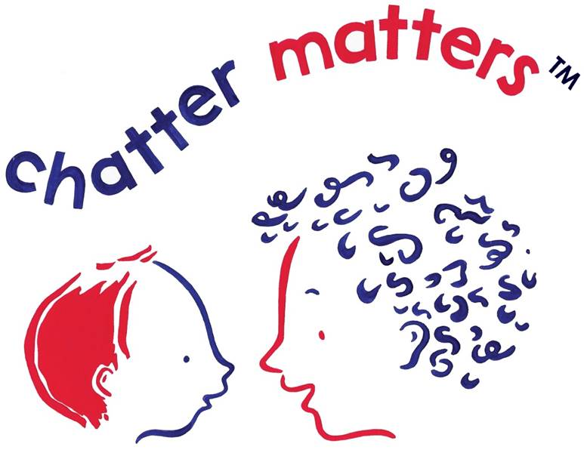
Remember Chatter Matters at Home

